Exploratory Data Analysis Report

Parental Education. Parental education is the proxy variable for Socioeconomical Status of a home. This variable measures the highest educational achievement of either parent. While, Parent Education Binary is a recoding of the variable with 1 representing parents with more than Upper Secondary Studies. On TIMMS data, for 2019 60% of the parents had more than Upper Secondary Studies, while on 2023 this number went up to 67%. More specifically, on 2019 35,7% of parents had university degrees or higher, 14,9% had Post secondary education, 24,7% had upper secondary education, 6,2% had lower secondary, 2,7% primary or none and 15% of the database was not administered this questionnaire.
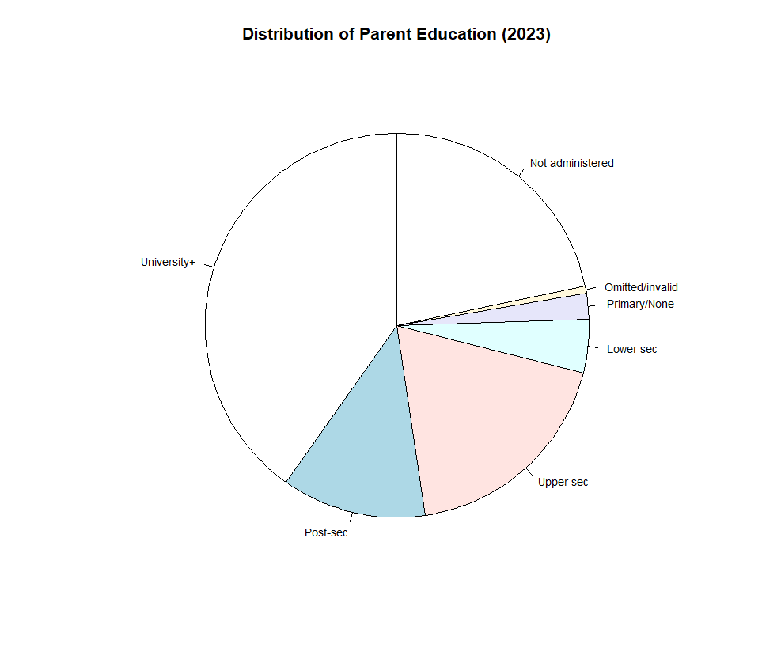
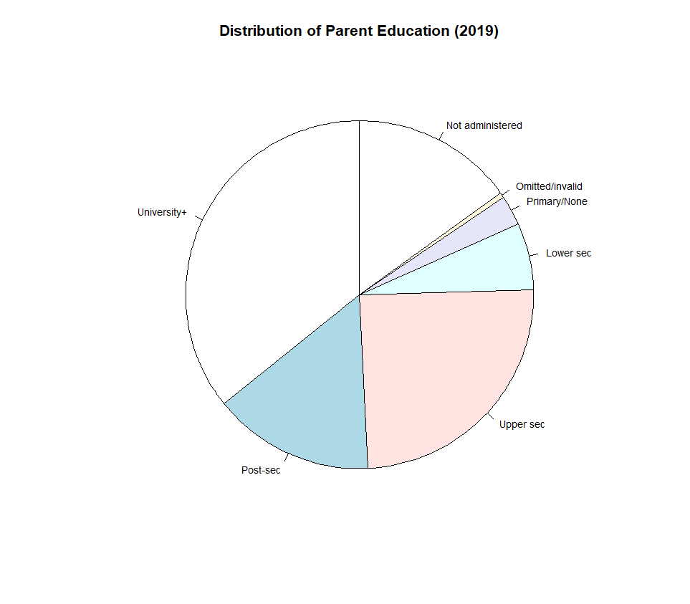
By year 2023, 40,2% of parents had university degrees or higher, 12,1% had Post secondary education; 18,7% had upper secondary education; 4,4% had lower secondary; 2,2% primary or none and 21,7% of the database was not administered this questionnaire.

The following tables shows the highest education distribution per country:
Meanwhile, this is the distribution for the binary variable for education:

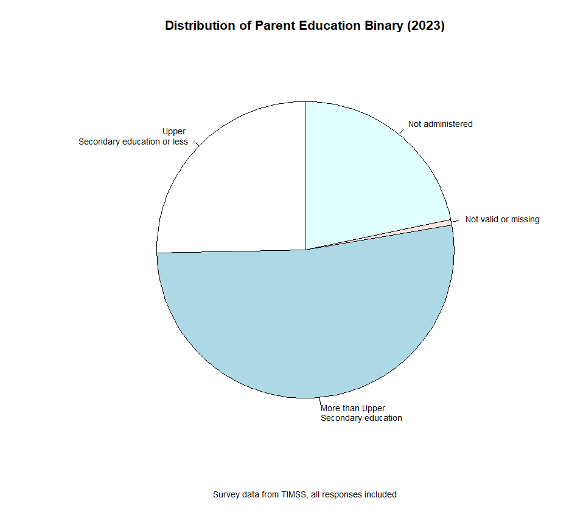
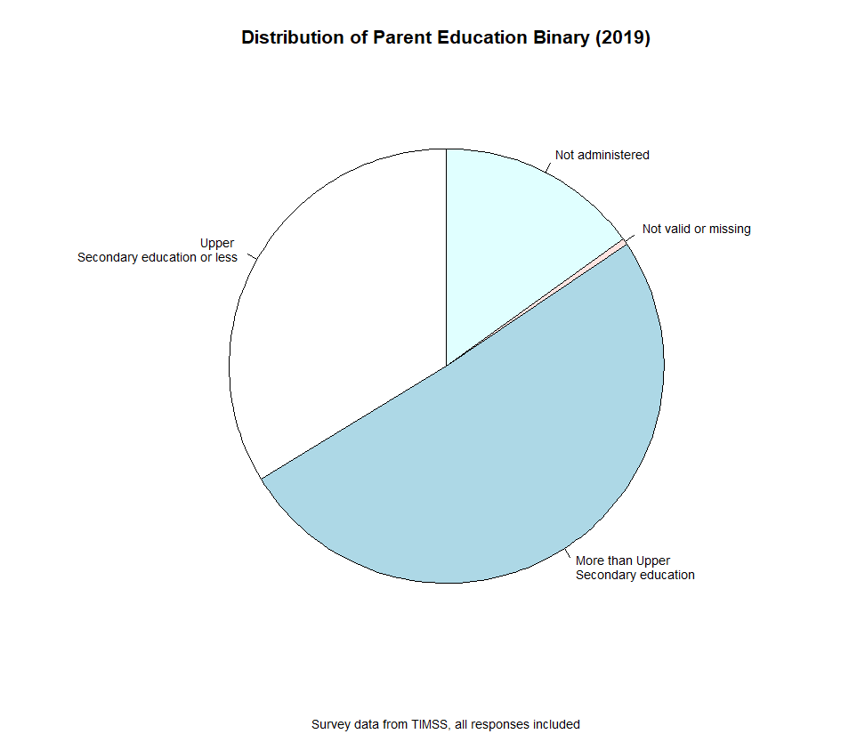
And the following are the tables of binary distribution per country:
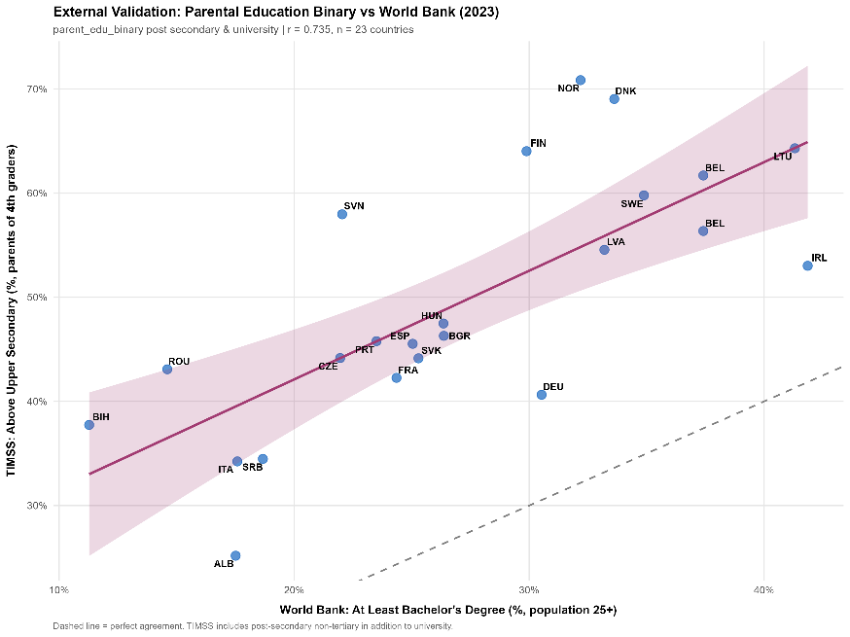
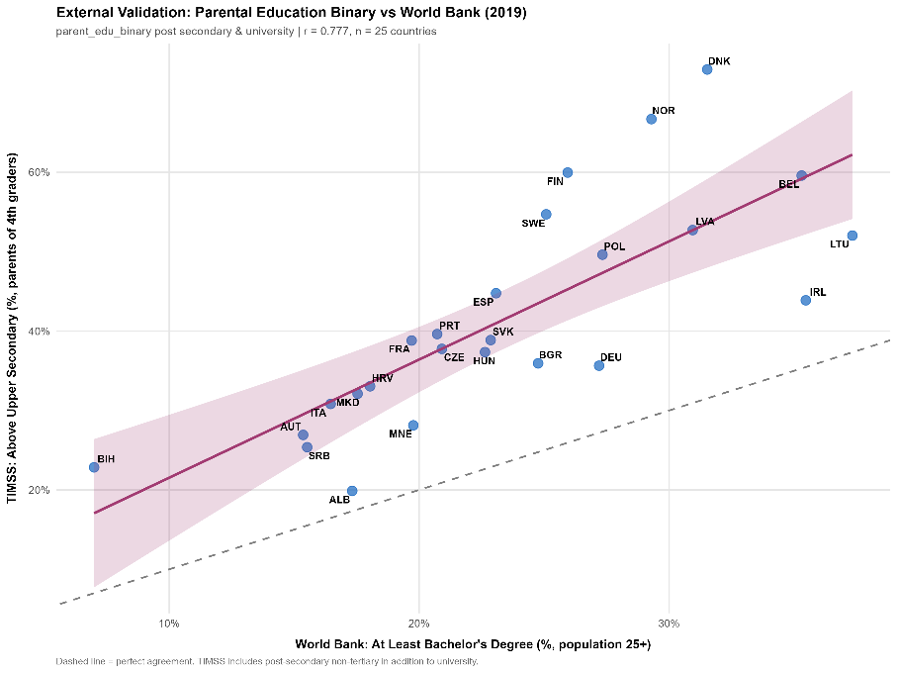
Now, for validation the binary variable has been corroborated with data from the world bank, running a correlation of the corresponding percentages to world bank data, we found a correlation of 77.7% on year 2019 and 73.5% on year 2023.

Parental Investment Index is calculated from the parental investment variables. These are separated by two categories, activities that help with reading and math related activities. Parents are asked on a scale from 1 to 3, where 1 is they never do such activity and 3 is often. For the index we consider Often as 1 and else as 0, and aggregate all 18 variables. The output is the Parental investment index on a scale from 0 to 18. The following tables represent the average Weighted mean answer of parents by country on both years.
While, tables X and X are the weighted average mean with parents of different

Now, we run regressions of math achievement. For that, we get the percentile distribution of the entire region, and run a linear regression using the parents education binary as dummy. This considers five plausible values of the math achievement, generates 150 replicates using the jackknife methods and combines the plausible regression values using Rubin’s rules. The gradient will estimate the math achievement difference between kids whose at least one of the parents has more than upper secondary education or not.
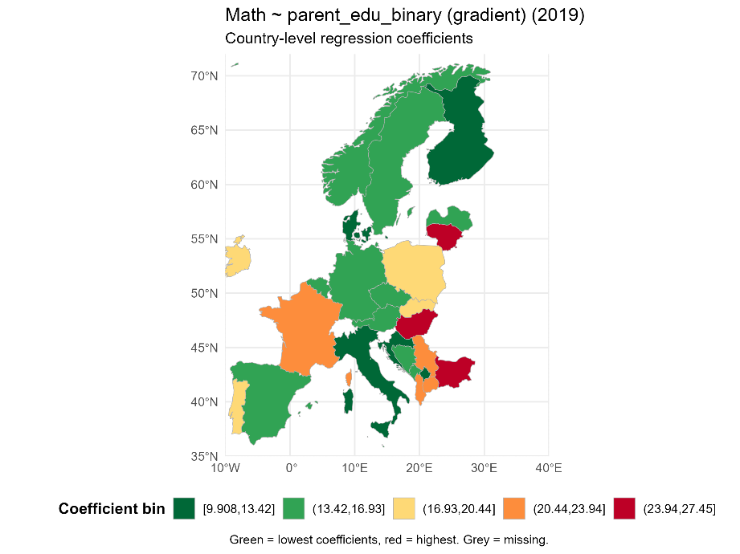
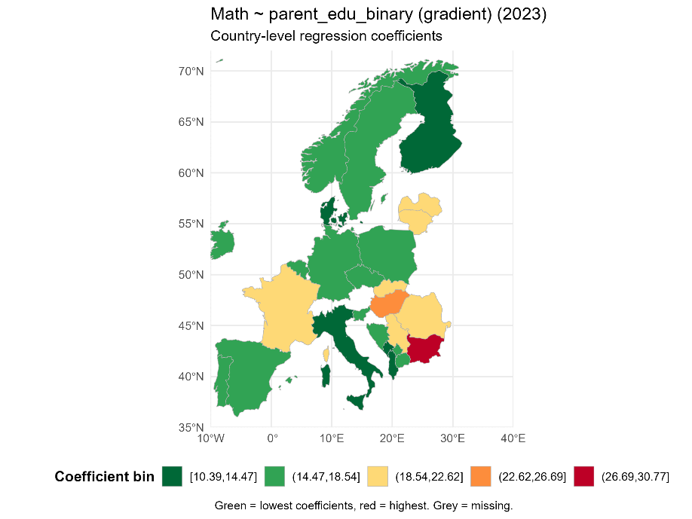

Now, gradients of the Parental Education binary to the Parental Investment Index:
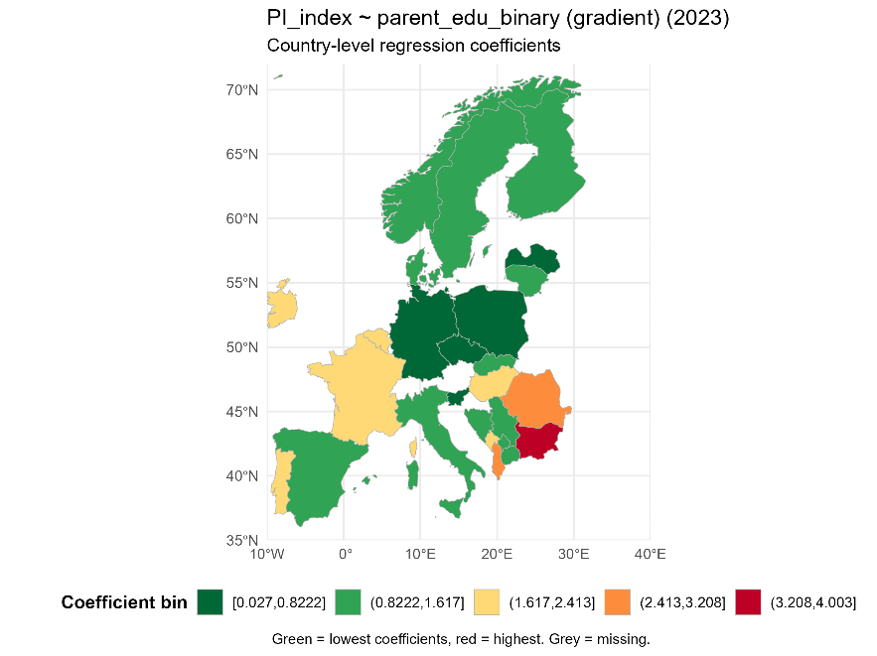
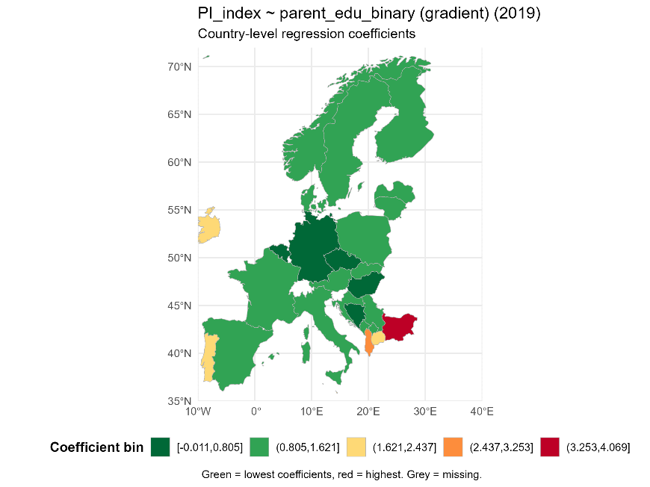

And, if we run correlations between the gradients from Math with Parental Education binary as a dummy and the gradients from Parental Investment Index with Parental Education binary as a dummy with get:

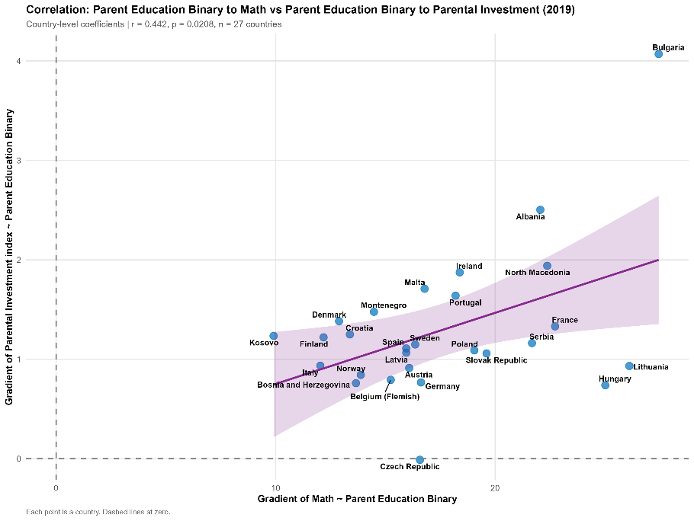
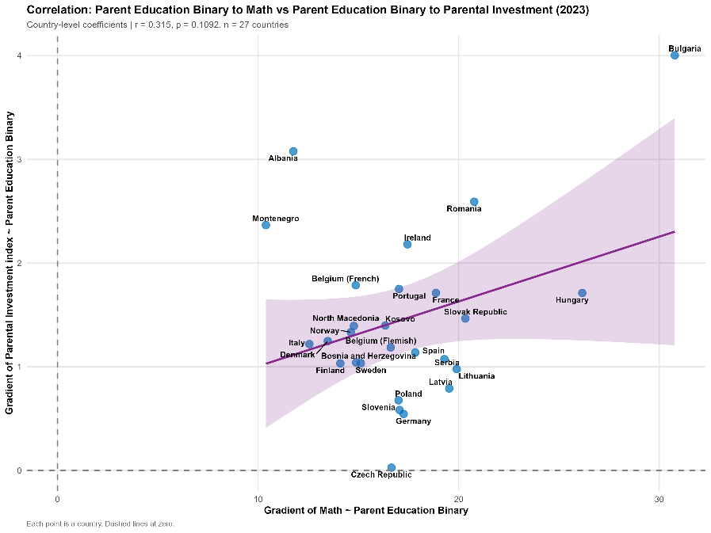
Missing values heatmap: